
QUALITY ALERT

Customer: HPAC Date: October 2, 2020
Die: 15191 / 15192 / 15238 Colour: ALL
Type of Complaint: HPAC REJECT

Q.A # Q.I.R # CUSTOMER NCR #

Description: Dimples on top visible surface
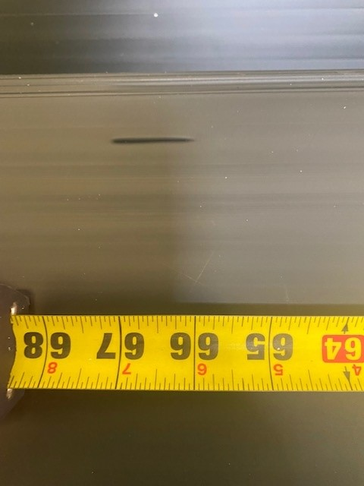
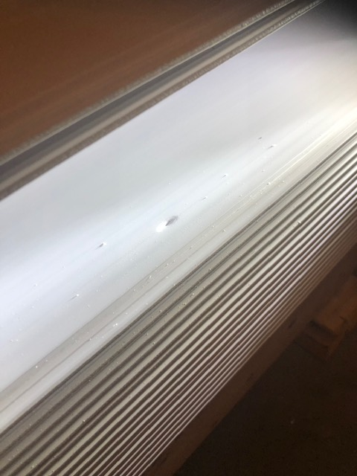
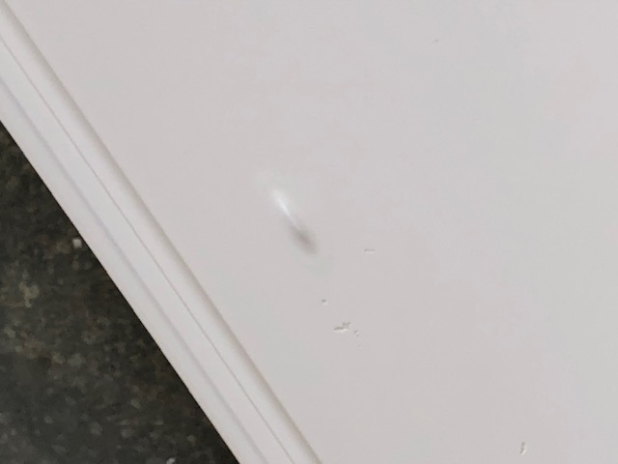

THE DIMPLES ABOVE ARE NOT ACCEPTABLE, MUST SCRAP ALL PIECES
BY SIGNING BELOW, YOU ACKNOWLEDGE THE PROBLEM ABOVE AND AGREE TO MONITOR THIS ISSUE IN FUTURE PRODUCTION RUNS.
DAY SHIFT |  | AFTERNOON SHIFT |  | NIGHT SHIFT
NAME | SIGNATURE | NAME | SIGNATURE | NAME | SIGNATURE

